# PROPOSED SOLUTION DOCUMENT

# Gas Leakage monitoring & Alerting system for Industries

ARDUINO UNO

POWER SUPPLY

LCD DISPLAY

# 

SENSOR MQ2

BUZZER

SENSOR MQ7

SENSOR MQ135

GSM MODULE

**Block Diagram of gas leakage detecting and alerting system**

This Figure represents the block diagram of the gas leakage detection and alerting system. Arduino UNO (Atmega-328) is the main unit of the system which performs the following tasks.

A signal conditioning of the Arduino UNO is done by output signal of the sensor, provided input to Arduino. The detection results displayed on LCD.

Indicates the people of danger in work place, factory, home. Buzzer activity with beep(siren) sound is made.

Also send alert SMS to the in charge of the plant whose number is saved in SIM card by using GSM modem. The SMS received depends upon the leak of gas in the detection area of the sensor.

### **HARDWARE DESCRIPTION**

**Arduino UNO:**

Microcontroller Arduino UNO is employed is shown in fig.2. The central unit of the system is Arduino board, where all the components are interfaced externally on the board and programmed as per their functionality to work in synchronization. it's an electronic prototyping platform/ board supported Atmega-328 which is of 8-bit, 16 Mhz. during this serial communication is enabled and has 14 digital input /output pins (out of which 6 are PWM) and 6 analog input pins. It operates at 5v. every pin contains a specific function to control.

The storage is non-volatile storage and EEPROM. The key comparison of a non-volatile storage with the EEPROM is that the incontrovertible fact that non-volatile storage contents are erasable. In contrast to a EEPROM, the entire device is erased. where one can erase and judge on bases of Byte and section. The availability of the non-volatile memory during which the blocks of the contains are divided and therefore block by block the portion is erased, where an no erased option is provided for the EEPROM byte. thanks to the actual fact that the programming of the non-volatile storage performed while it’s on the system board socket. BIOSROM of the PCB is the new upgrade which is immensely used.

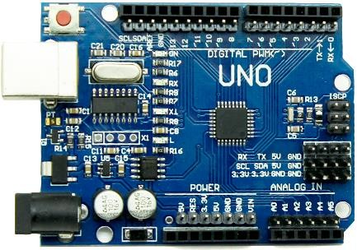

Arduino Uno

***MQ2 Sensor****:* MQ-2 gas sensor module is shown in fig.3. It is a sensor detector used to detects the flammable gas and smoke concentration of the combustible gas in the air, and output is read in the analog voltage and digital value output. Supply input voltage is 5v. it is very sensitive to H2, LPG, CH4, CO, SMOKE, PROPANE. It has three pins for transmitter, receiver, ground and sensitivity can be adjust by the potentiometer. Detects LPG from 200ppm to 10000ppm.

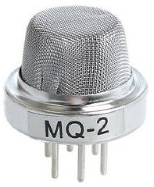

MQ-2 Gas sensor

**GSM Module:**

SIM900 GSM module is employed to send SMS alerting on gas detection. GSM is meant as a device used for exchanging the information. SIM card is recovered from the GSM to control the wireless node 5 volts of the DC supply is required by the GSM for functioning. The modem needs only three connection (transmitter, receiver, ground) to interface with Arduino controller Atmega-328 the excess power supply is used. Arduino microcontroller is connected with the receiver pin to the device. The Arduino provide information to the GSM device [2]. The GSM will send an output to through the SIM inserted into its SIM slot to number written into the code to alert about the leakage of the LPG gas or the other gas sensed by the sensor. AT commands are accustomed communicate with GSM module and it's shown in figure .

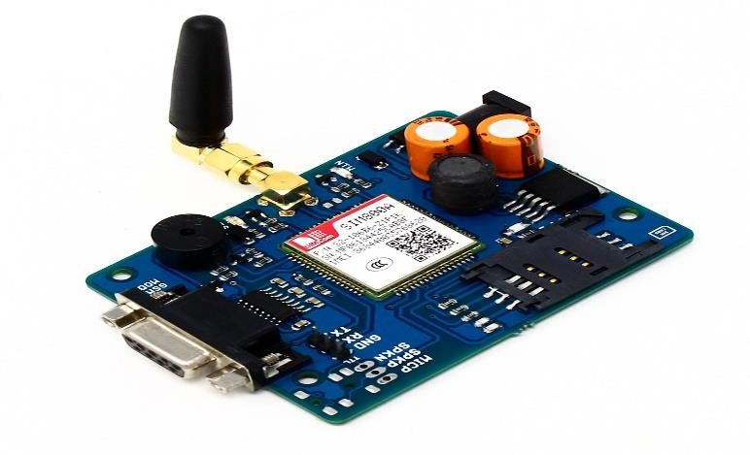

SIM900A Quad Band GSM/GPRS Module with RS232 Interface

**Buzzer:**Buzzer is used to alarm the beep sound to indicate and warn the danger to the people working around. The buzzer is the output of the system. The sound of the buzzer is beep-beep, which indicates the danger.

*LCD:* LCD is employed for displaying the message indicating that” gas detected at zone” into the display, which is initially coded in program to display the danger. The message been displayed on the LCD, data and command both are register of LCD and it's shown in fig.5. The register selects is employed to modify the registers. data register RS=1, whereas for the command register RS=0 is employed.

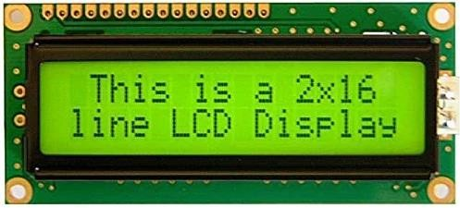

16x2 LCD display

### Software Implementation

Figure 6 shows the chart flow of implementation of the software proposed system. This system monitors the gas, smoke by sensor 1, sensor 2, sensor 3. If any gas is detected the signal of sensors goes low and activate the Arduino UNO. Which send signals to the LCD (“GAS DETECTED AT ZONE), where sensor 1 is for zone 1, sensor 2 for zone 2 and sensor 3 for zone 3 respectively, Buzzer and GSM to alert the people about danger and if no gas is detected then LCD displays “NO GAS DETECTED” in its 16x2 display.

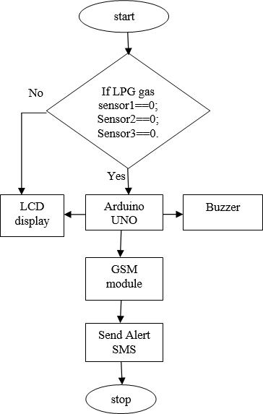

Flow Chart of Proposed System

**NOVELTY:**

**1,** With an industry a bright LED display, the ULTIMA X5000 Gas Monitor makes it easier than ever to view plant safety data. The field of view of this new generation of LED displays improves visual ergonomics for technicians who are often working under challenging plant conditions. The X5000’s text and icons show a gas reading gauge, progress bar, operational status, maintenance alerts and alarms.

2, In this project in case server will loss , it make call to user or main worker under challenging condition. It notify the emergency call. MQ-5 gas sensor will start scanning for any gas leakages found in the system installed area.

**SOCIAL IMPACT:**

Only one gas can be measured with each instrument. When heavy dust, steam or fog blocks the laser beam, the system will not be able to take measurements. This is also the case when a person or vehicle blocks the path.